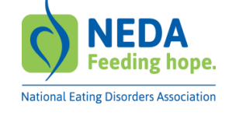
2023 Feeding Hope Fund
Frequently Asked Questions

When does funding begin?
Funding begins in 2024 after the institution has completed the required grant award paperwork.
Can I apply as a PI or Co-PI on more than one application?
You are allowed to apply as a PI or Co-PI on more than one application but can only be awarded one grant.
Is there a budget worksheet for the LOI?
Applicants in round 2 (grant submission round) will complete a detailed budget worksheet which will be provided with the instruction packet. A budget narrative with details is required for the LOI.
What can be included in the budget description?
Description of the funding needs of the project and total amount of request should be included in the LOI. Allowable costs include staff, equipment, supplies, travel, inpatient/outpatient care costs, and other expenses (direct costs). Indirect costs should not exceed 10% of the total budget. The budget should reflect the salary and fringe benefits and percentage of time for all parties involved in the grant.
Are bio-sketches required for all participants?
Yes, a bio-sketch is required for every participant – PI, Co-PI, graduate student, consultant, etc.
I am a non-citizen, can I apply?
Non-citizens cannot be the PI or Co-PI but may participate as a paid consultant.
Is a reference list in addition to the 2-page LOI submission allowed?
You may submit references to support your submission however, the review committee prefers that you keep your LOI submission to no more than two pages. If you can fit a reference list in the allowable space, then it is permitted. References as a separate document are not allowed.

