NEDA

3rd Party Event Guide

A GUIDE TO DIY PLANNING AND FUNDRAISING

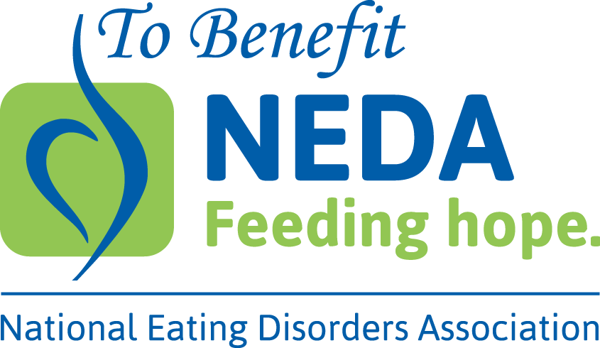
Welcome
The National Eating Disorders Association
200 W. 41st Street, Suite 1203
New York, NY 10036
212.575.6200
clillis@myneda.org
501(c)(3); Tax ID #: 13-3444882
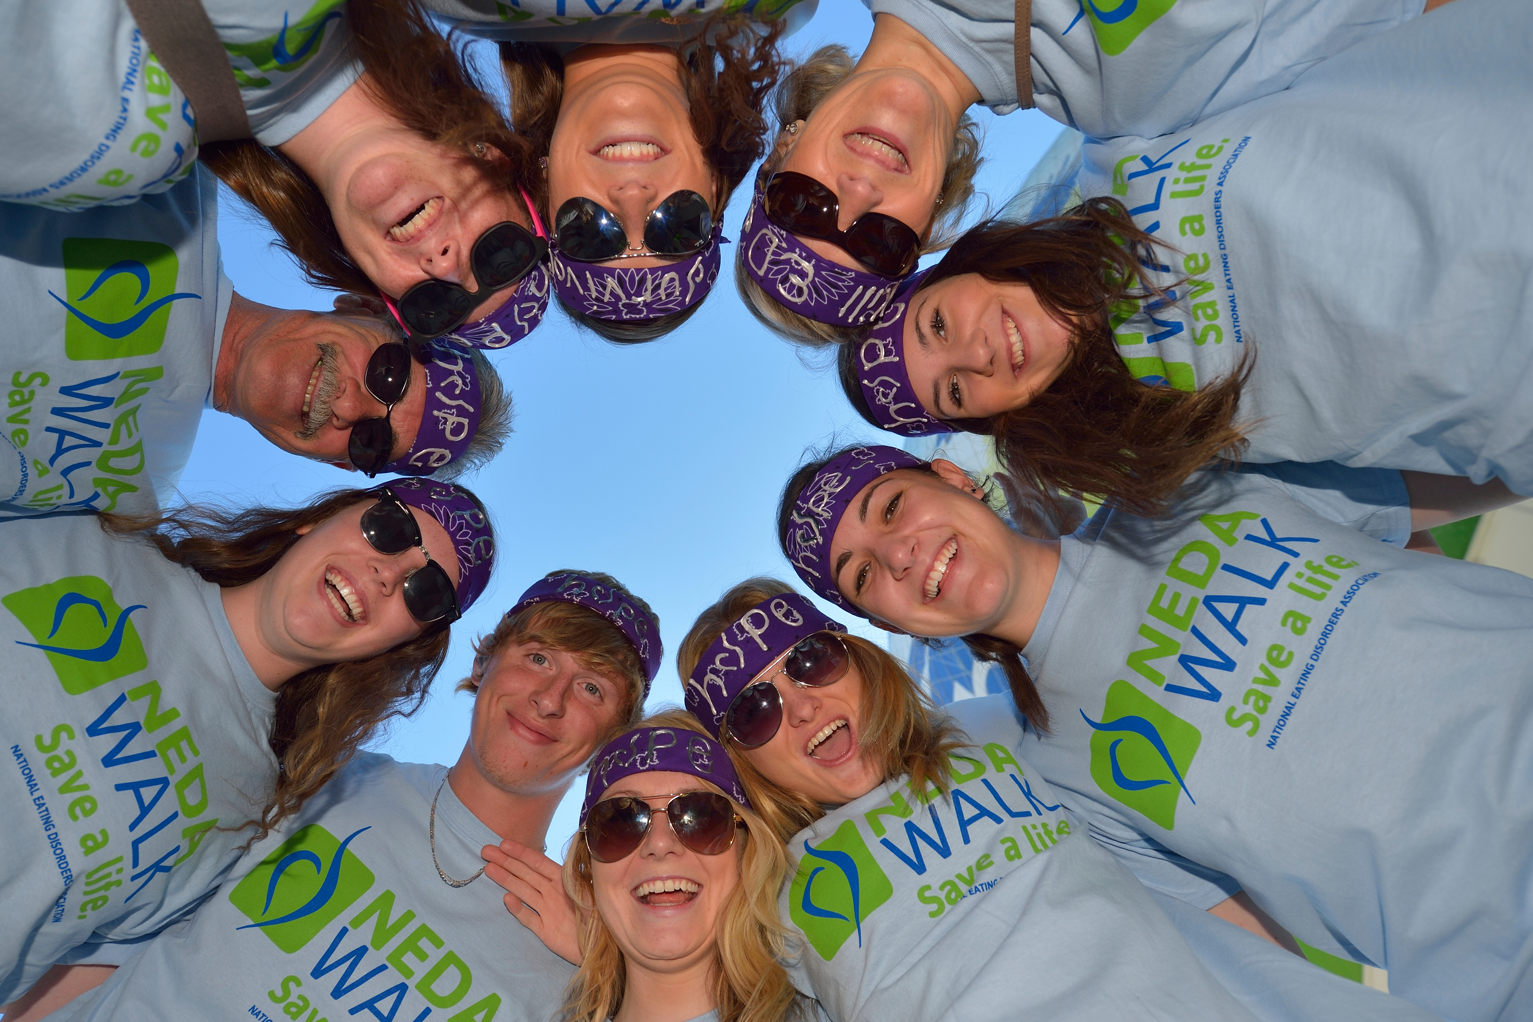
Top Reasons to Host a 3rd Party Event
- 20 million women and 10 million men in the U.S. will suffer from a clinically significant eating disorder at some time in their life

- Anorexia Nervosa has the highest mortality rate of any mental illness

- Children as young as 7 are showing signs of the disease

- Dieting & body dissatisfaction are among the greatest risk factors for developing an eating disorder

- Eating Disorders don’t discriminate. They affect all socio-economic levels and ethnicities including Hispanics, African-Americans and Asians at similar rates, and in addition can begin in early childhood and last into mid-life and beyond

- The NEDA Helpline receives thousands of calls for guidance and treatment referrals

- Families of those who are struggling turn to The Parents, Friends & Family (PFN) Network for information and support

AND…

- Recovery is possible! If clinical research and training is secured and programs are in place we can reach those in need and help to put an end to the suffering caused by eating disorders

BY HOSTING A 3rd PARTY EVENT YOU ARE A PART OF THE SOLUTION!

To benefit neda

A Third Party Event is any event initiated, organized, promoted and executed by an outside individual or group (not NEDA) where the funds raised are donated to the National Eating Disorders Association (NEDA).

What Is a 3rd Party Event?
Hosting a 3rd Party Event
A 3rd Party Event is any event initiated, organized, promoted and executed by an outside individual or group (not NEDA) where the funds raised are donated to the National Eating Disorders Association (NEDA).

- 3rd Party Events are independent of NEDA involvement

- NEDA does not pay for any production costs of the event (guest speakers, venue, rentals etc.). We suggest you secure donations and sponsorships on advance to cover the costs.

**Please note: It is very important to vet all sponsors and exhibitors, as well as speakers and performers. We must make sure that before your event occurs, these individuals and organizations are in alignment with our mission. This is preventative. Also, be sure to inform anyone who is speaking, on what an eating disorder is and what triggers could be.

Please know that any exhibitor, participant, speaker, performer or sponsor that you, as a coordinator, feel may trigger your audience in terms of eating disorders, can be asked to leave.

You have the right to ask anyone associated with inappropriate behaviors or products (such as diet or weight loss materials) to leave the event that day.

Contact the NEDA staff member using the e-mail on the cover of this PDF and give notice that you would like to do a 3rd Party Event for NEDA at least 6 weeks prior to the event date.
Hosting a 3rd Party Event

Upon notification, you will receive this guide and be requested to fill out the last two forms of this document titled “NEDA 3rd Party Agreement Form.” The agreement must be received by NEDA no later than one month prior to the event date.

Need An Idea For An Event?

Want to do a 3rd Party Event but have no idea what event to do to raise money for NEDA? Try one of our “In a Box” events. “In a Box” events are tried and true fundraising events that you can customize to suit your needs and raise money for NEDA. Before deciding on what event to move forward with think about the following things:

- How much time do you have to put together the event?

- Who can help you organize the event? Can you put a team in place?

- How much time do you have to fundraise?

- Who or what organizations do you know that could donate time, services or goods to an event?

No matter what type of event you do, remember to always thank any sponsors, or anyone who has donated a large amount of their time helping you to create a successful event!

*Be sure to submit your invitation, flyers and anything else that has the To Benefit NEDA logo or information on it to be approved by NEDA at least one week in advance of your print date.

You can collect donations at your event for NEDA via two ways: check or cash.
Sending Money Raised To NEDA

If you accept cash donations please make sure you have a form that documents each individual donation, who made the donation (their name, mailing address, etc.) and how much they donate.

Once all of the cash has been collected and the cash form filled out please use the cash and obtain a cashier’s check or money order for the full amount made out to NEDA.

All check donations should be made out to NEDA directly. A form should be kept to keep track of all of the checks that are coming in and the corresponding information (sender name, address, phone number, email address).

Please send all checks and the cashier's check together to the Special Events Associate at NEDA with all other donation documentation.

**Please note that hosts of 3rd Party Events should never deposit cash donations into their personal accounts and write a personal check for the full amount to NEDA.

Should someone want to donate via credit card, please call our office at 1.212.575.6200 for processing over the phone.

Ideas for Maximizing Your Fundraising
1 Ask Face-to-Face  Highest on the fundraising “ladder of effectiveness” is a request for support in person. Your chances for success are greatly enhanced by making a request face-to-face. It is harder to say “no” to someone in person! Unable to meet face-to-face? You can use email and letters to contact larger businesses and groups! | 4 Email Signature  Direct everyone you communicate with through email to support your event. Add a note to your email signature asking for donations or an invite to the event!
2 Inner Circle  Who can you ask to support your event? Your friends, significant other, parents, siblings, neighbors, aunts, uncles, cousins, coworkers, family doctor/dentist, clubs you belong to, etc. People love a great cause and the gifts are tax-deductible! | 5 Birthday Pledge  Do you or someone you know have an upcoming birthday? Ask for donations to your event instead of a gift!
3 Honor a Loved One  Ask around if someone wants to make a tribute gift honoring a loved one who struggled with body image or an eating disorder. The honoree will receive a congratulatory note in the mail! If they have lost a loved one due to an eating disorder, they can make a memorial gift in honor of the person who passed away. | 6 Matching-Gift Program  Ask your Human Resources department if your company has a matching gifts program. You can easily double any amount you’ve raised with no added effort! And remember, this is something your donors can inquire about as well!

Fundraising Ideas

WEB OF FRIENDS
Continue to ask your teammates to invite their family, friends and coworkers. Asking someone personally to join your team may be more successful than posting a general group social media post. If someone likes or retweets your post but didn’t join your team, personally send a private message asking them if they would like to join!

SHARE YOUR SUCCESS
We all love success stories! Whenever you and your team hit a goal, share it on Facebook, Twitter and your other online communities to raise even more money for your team. Someone may be watching and get inspired themselves!

WHY IT MATTERS
Participating and fundraising for a NEDA Walk is a great way to show your passion for helping others. If you have a personal story, be sure to check out our Guidelines for Sharing Your Story Responsibly. When talking to someone about a donation, make sure to tell them why you care and why you’re involved. Your passion and drive may inspire others to contribute and get the word out themselves!

IT’S OKAY TO HEAR “NO”
You may may be hesitant to ask for donations in fear of rejection. Remind them that it’s okay to hear a few declines. Maybe the first four people who declined to give you $20 results in the fifth person offering to make a $100 donation! And remember, any donation, big or small, makes an impact! Make sure to make it as easy as possible by giving them a link to your team website.

Event Ideas

“In The Box” Event Ideas - Brown Bag Day/ Week:

Want to have a fundraising event, but have very little spare time to coordinate a big event or solicit sponsors? If so, this event is for you. It is very easy and relies on you, like all events, to get the word out and push for involvement.

Designate one day or one week to be the brown bag day/ week.

Ask all of your co-workers and friends to bring in their lunch on the designated days and donate what they would have spent on lunch out to NEDA.

Create fun incentives, like a gathering place for people to get together to have their lunch rather than eating at their desks. Maybe this is a gathering place in your office or at the park around the corner.

Get sponsors. A local deli may be interested in donating one catered lunch to your office during this week (This is a great marketing opportunity as the local deli will get their name out to those who may think about them for lunch the next week).

If lunch is too hard you can do a No Latte Day and ask people to give up their coffee, latte or tea for the day and donate that money to NEDA! This is a great idea that requires very little time on the participants behalf.

Cause-Related Marketing Events:
This type of event is similar in ease to the brown bag day except that it does require partnering up with a local retail outlet. Once you have the relationship built all you need to do is promote the store and the event! The more you promote the more successful it will be!

Work with a retail store ( convenient store, nail salon, clothing store etc.) and designate a certain period of time, whether it is one day for a few hours or for a week, where a percentage of the proceeds made during the designated time are donated to NEDA.

Example: $1 of every purchase is donated to NEDA or 10% of every sale is donated to NEDA between the hours of 3-6PM, Monday – Friday of a specific week.

Event Ideas

Your responsibility would be to promote the store and the designated time (s) that the percentage of proceeds will be donated.

It is a win- win situation! The store gets additional advertising and new people in their doors and you raise money!

Host a House Party
Hosting a house party, such as a cocktail reception or a Sunday brunch, is a great way to introduce new people to the cause, raise awareness and raise funds!
Establish a simple checklist of things that need to get done, such as sending out evites, if desired.
- Having the event as a potluck is always a great way to get people involved and reduce the time and cost on your end.
- A Sunday Brunch is another sure fire success with little cost! With coffee, juice, pastries and fruit you can’t go wrong.

House parties are meant to be private events hosted at a personal residence so invite your personal friends as well as local people who are prominent supporters of the cause.

Try to get a guest speaker. This can be someone local involved in the fight against eating disorders such as a community member, a psychologist, doctor or college health professor. Someone who can speak to the prevalence and danger of the disease.

Send out invitations via email or mail with an RSVP. The invite should include:
- An RSVP/ response action which can either be full-filled via a supplied reply card or via email. ** Please make sure that you ask for the name, address, phone number and email address of those RSVP’ing.
- Don’t forget to give an opportunity for those to donate in lieu of attending.
- Once this event is over, send this information to NEDA along with the donations.
- Indicate on the invite that a suggested donation in the amount of (event hosts choosing) will be requested.

Event Ideas

When inviting people, ask each person to invite one or bring one person. This will help expand your guest list!

Make sure you have a guest list/ sign in sheet on the night of the event.

Don’t See An Event You Want To Host?

If you want to take a more personal approach to fundraising here are some additional ideas.

- Host a bowling night
- Have a yard sale
- Host a fashion show
- All size fashion show
- Mother daughter fashion show
- Father son fashion show
- A benefit dinner at a local restaurant

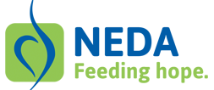
ABOUT NEDA
WHO we are
NEDA is the largest not-for-profit organization in the United States advocating to prevent eating disorders and to provide support to individuals and families suffering from eating disorders as well as those concerned with body image and weight issues.

WHAT WE DO
We serve the needs of communities throughout the United States by providing programs, products, and services of superior quality that work to prevent, treat, and find a cure for eating disorders. NEDA campaigns for early intervention, improved access to quality treatment, and increased research funding to better understand and treat eating disorders. All of this vital work is done through working with partners and volunteers like you to develop programs and tools to help everyone who seeks assistance.

AN ORGANIZATION YOU CAN TRUST
For the 2nd year a row, NEDA has received a four-star rating from Charity Navigator - a distinction only 18% of nonprofits can claim. Click here to see our profile!

OUR MISSION
The mission of NEDA is to support individuals and families affected by eating disorders and serve as a catalyst for early intervention, cures and access to quality care. NEDA envisions a world without eating disorders. In the United States 20 million women and 10 million men suffer from a clinically significant eating disorder at some time in their life.
WHY IT MATTERS
The scope and severity of eating disorders is often misunderstood. Eating disorders are a serious illness, not a lifestyle choice, and in fact anorexia has the highest mortality rate of any mental illness. Children as young as seven years old are at risk. NEDA confronts these serious illnesses with increased awareness, early interventions and improved access to treatment. We provide programs and services to give families the support they need to find the answers they are looking for with these life-threatening illnesses.

HOW TO GET HELP
Professional treatment, education and support are vital for the greatest chance of recovering from an eating disorder. Learn about NEDA’s programs and services to give families and loved ones the support they need to find the answers they are looking for with these life-threatening illnesses by contacting NEDA at nationaleatingdisorders.org or by calling our toll free, confidential Helpline at 1-800-931-2237.

NEDA 3rd Party Agreement Form
_________________________ agrees to donate the amount of proceeds as agreed upon with NEDA, from an event to benefit the National Eating Disorders Association and requests the use of the NEDA name and the ‘To Benefit NEDA logo’ in educating and marketing of the event.
- NEDA’s name or logo may not be imprinted upon or used in association with any products, goods or services offered by the host without prior written approval from NEDA. NEDA reserves the right to request the use of our logo to be removed should NEDA see any materials or written statements associated with the above stated event, that does not align with NEDA’s core beliefs and mission.

- NEDA must review and approve all promotional materials that use the name and/or logo of NEDA prior to production, printing and publication, including, but not limited to print and electronic media advertisements, letters, news releases and promotional packaging.

- The use of the NEDA logo must be consistent with NEDA’s graphic standards:
- There may be no modification of the NEDA logo, changes in size must be proportional and colors must not deviate from the PMS colors of NEDA.
- Whenever possible, the full name “National Eating Disorders Association” should also appear next to or somewhere near the logo.
- If appearing electronically (email or website), a link must be provided to NEDA’s website.

- You agree to forward the agreed upon percentage of the donations to the National Eating Disorders Association within ten business days after the date of the event (or the date of the donations whichever is earlier).

- Acceptance of contributions or sponsorship will not imply an endorsement of the company, its products or its services.

- You agree to comply with all federal, state and local charitable solicitation statutes, regulations and ordinances that affect or apply to you and the fundraising activities that you are involved with.

- Funds will be sent to the following address: NEDA, 200 W 41st Street, Suite 1203, New York, NY 10036. Checks will be made payable to the National Eating Disorders Association.

- I, individually or as a representative of the below named business or organization, agree to the above requirements and herby fully release and agree to hold harmless the National Eating Disorders Association, its officers and directors, employees, representatives and successors, of and from any and all liability, claims, damages, expense or causes of action for any reason.

Name and Date: ________________________________________________________
NEDA 3rd Party Agreement Form

Business or Organization (if applicable): _______________________________________

Third Party Event Name: ____________________________________________________________

Event Location (Full Address): ________________________________________________

Event Date: ________________

Event Start Time: ______________ Event End Time: ______________

Event Fundraising ($) Goal: ______________Percentage of Donated Funds: _________ ____

Event Description:
_____________________________________________________________________________________________________________________________________________________________________________________________________________________________________________________________________________________________________________________________________

Event Coordinator Contact Information
Name:____________________________________________________________

Signature: _________________________________________________________

Address: ________________________________________________

City: _______________ State: _________ Zip Code: _____________

Primary Phone Number: _________________________

Email: ___________________________________________________

